*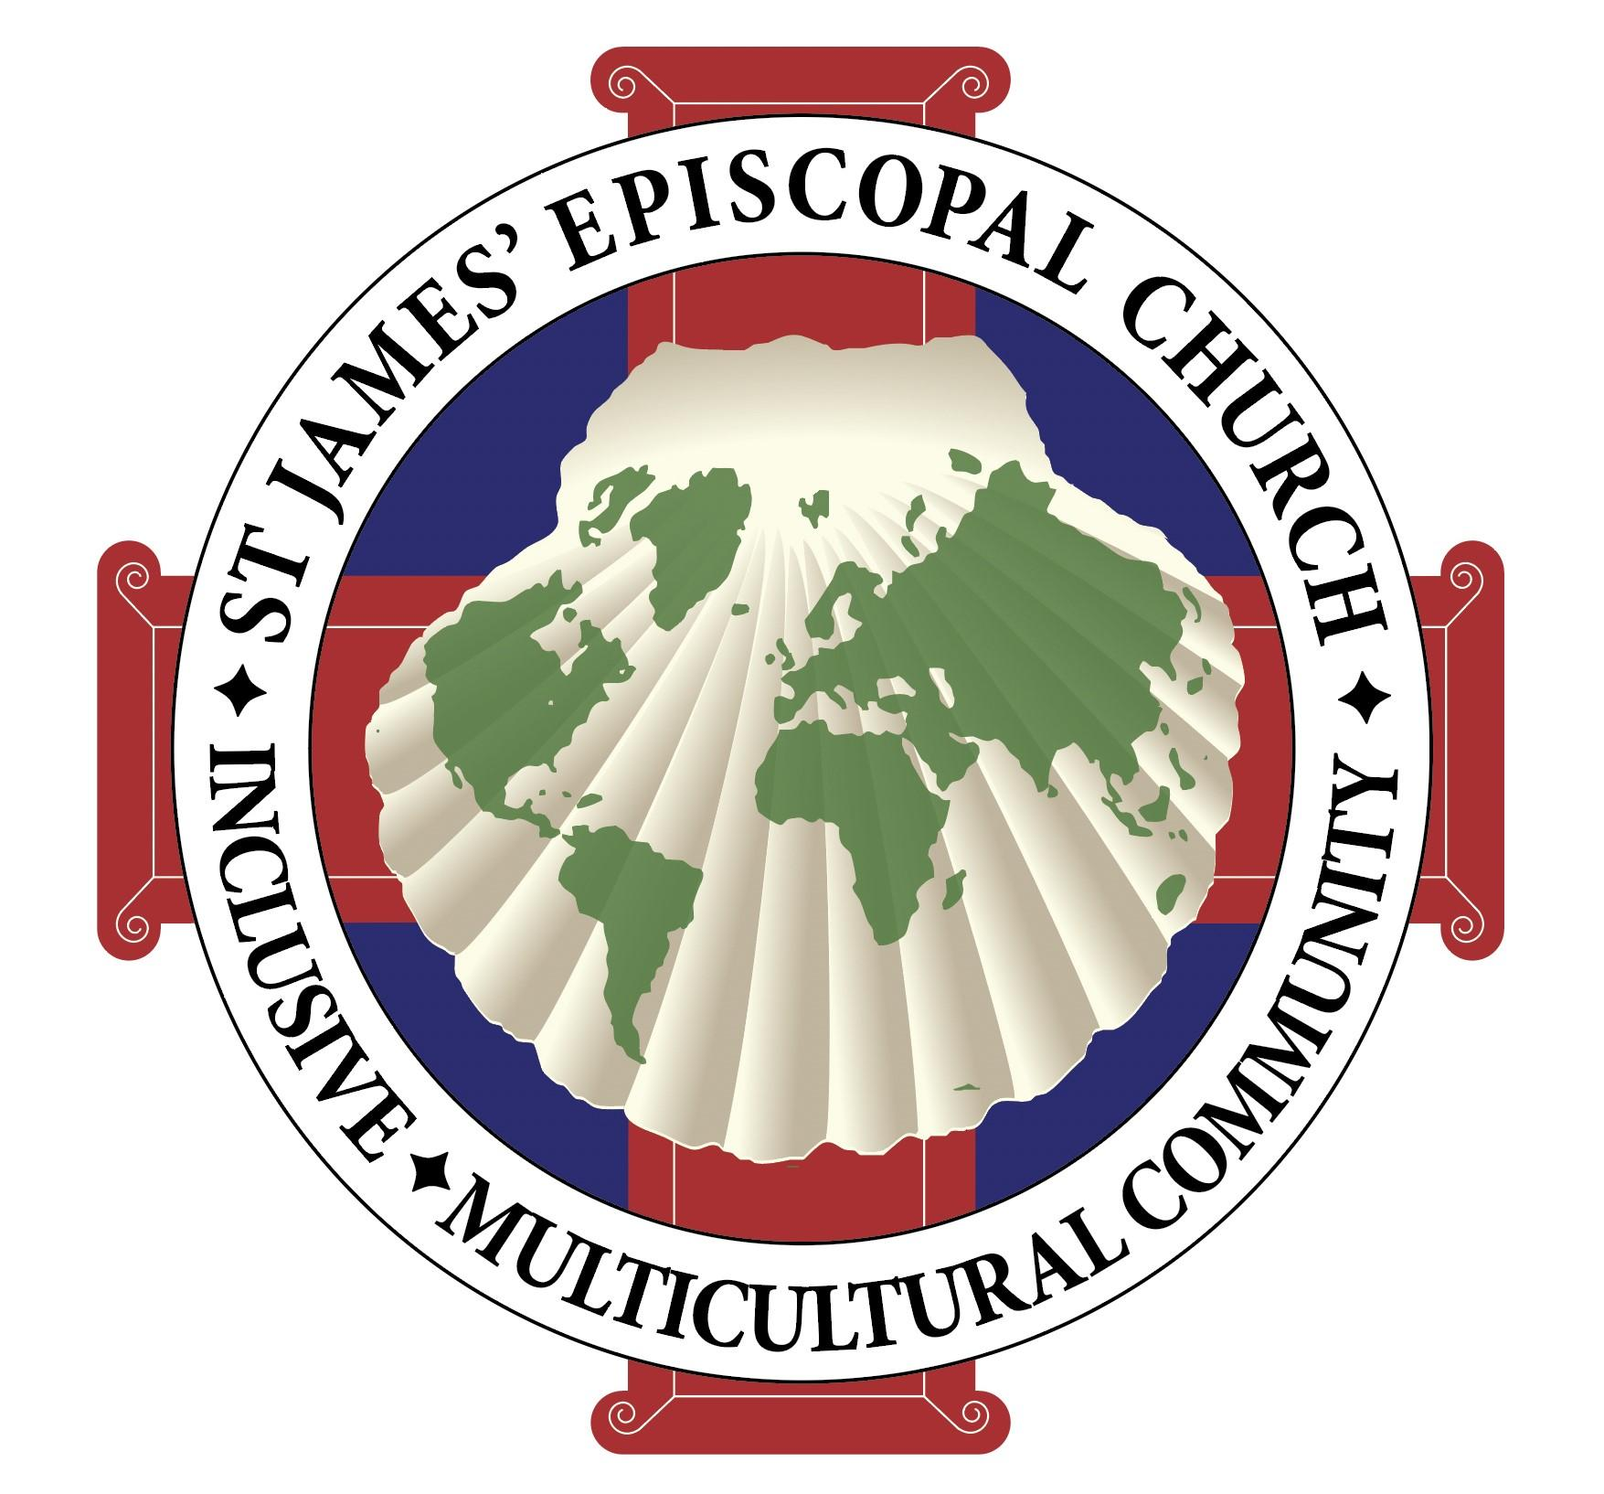s*

**St. James’ Episcopal Church**

**October 6, 2024**

**10:30 am**

**Twentieth Sunday after Pentecost**

***Wherever you are on your journey of faith, you are welcome at this table.***

*All creatures of our God and King* verses 1,4,5, and 7H400

**The Word of God**

Celebrant Blessed be God: Father, Son, and Holy Spirit.

**People And blessed be God’s kingdom, now and for ever. Amen.**

**The Collect for Purity**

Celebrant Let us pray.

**Almighty God, to you all hearts are open, all desires known, and from you no secrets are hid: Cleanse the thoughts of our hearts by the inspiration of your Holy Spirit, that we may perfectly love you, and worthily magnify your holy Name; through Christ our Lord. Amen.**

**The Collect of the Day**

Celebrant The Lord be with you.

**People And also with you.**

Celebrant Let us pray.

Almighty and everlasting God, you are always more ready to hear than we to pray, and to give more than we either desire or deserve: Pour upon us the abundance of your mercy, forgiving us those things of which our conscience is afraid, and giving us those good things for which we are not worthy to ask, except through the merits and mediation of Jesus Christ our Savior; who lives and reigns with you and the Holy Spirit, one God, for ever and ever. **Amen***.*

*Please be seated for the readings.*

### **The First Reading** Job 1:1; 2:1-10

Lector A reading from the Book of Job.

There was once a man in the land of Uz whose name was Job. That man was blameless and upright, one who feared God and turned away from evil.

One day the heavenly beings came to present themselves before the Lord, and Satan also came among them to present himself before the Lord. The Lord said to Satan, “Where have you come from?” Satan answered the Lord, “From going to and fro on the earth, and from walking up and down on it.” The Lord said to Satan, “Have you considered my servant Job? There is no one like him on the earth, a blameless and upright man who fears God and turns away from evil. He still persists in his integrity, although you incited me against him, to destroy him for no reason.” Then Satan answered the Lord, “Skin for skin! All that people have they will give to save their lives. But stretch out your hand now and touch his bone and his flesh, and he will curse you to your face.” The Lord said to Satan, “Very well, he is in your power; only spare his life.”

So Satan went out from the presence of the Lord, and inflicted loathsome sores on Job from the sole of his foot to the crown of his head. Job took a potsherd with which to scrape himself, and sat among the ashes.

Then his wife said to him, “Do you still persist in your integrity? Curse God, and die.” But he said to her, “You speak as any foolish woman would speak. Shall we receive the good at the hand of God, and not receive the bad?” In all this Job did not sin with his lips.

Lector The Word of the Lord.  
**People Thanks be to God.**

**Psalm** Psalm 26

Give judgment for me, O Lord,

for I have lived with integrity;

I have trusted in the Lord and have not faltered.

**Test me, O Lord, and try me;**

**examine my heart and my mind.**

For your love is before my eyes;

I have walked faithfully with you.

**I have not sat with the worthless,**

**nor do I consort with the deceitful.**

I have hated the company of evildoers;

I will not sit down with the wicked.

**I will wash my hands in innocence, O Lord,**

**that I may go in procession round your altar,**

Singing aloud a song of thanksgiving

and recounting all your wonderful deeds.

**Lord, I love the house in which you dwell**

**and the place where your glory abides.**

Do not sweep me away with sinners,

nor my life with those who thirst for blood,

**Whose hands are full of evil plots,**

**and their right hand full of bribes.**

As for me, I will live with integrity;

redeem me, O Lord, and have pity on me.

**My foot stands on level ground;**

**in the full assembly I will bless the Lord.**

**The Second Reading** Hebrew 1:1-4, 2:5-12

Lector A reading from the Book of Hebrews.

Long ago God spoke to our ancestors in many and various ways by the prophets, but in these last days he has spoken to us by a Son, whom he appointed heir of all things, through whom he also created the worlds. He is the reflection of God’s glory and the exact imprint of God’s very being, and he sustains all things by his powerful word. When he had made purification for sins, he sat down at the right hand of the Majesty on high, having become as much superior to angels as the name he has inherited is more excellent than theirs.

Now God did not subject the coming world, about which we are speaking, to angels. But someone has testified somewhere,

“What are human beings that you are mindful of them,  
 or mortals, that you care for them?

You have made them for a little while lower than the angels;  
 you have crowned them with glory and honor,  
 subjecting all things under their feet.”

Now in subjecting all things to them, God left nothing outside their control. As it is, we do not yet see everything in subjection to them, but we do see Jesus, who for a little while was made lower than the angels, now crowned with glory and honor because of the suffering of death, so that by the grace of God he might taste death for everyone.

It was fitting that God, for whom and through whom all things exist, in bringing many children to glory, should make the pioneer of their salvation perfect through sufferings. For the one who sanctifies and those who are sanctified all have one Father. For this reason Jesus is not ashamed to call them brothers and sisters, saying,

“I will proclaim your name to my brothers and sisters,  
 in the midst of the congregation I will praise you.”

Lector The Word of the Lord.

**People Thanks be to God.**

*O love, how deep, how broad, how high* verses 1-3, 6 H448

### **The Gospel** Mark 10:2-16

Deacon The Holy Gospel of our Lord Jesus Christ according to Mark.

**People Glory to you, Lord Christ.**

Some Pharisees came, and to test Jesus they asked, “Is it lawful for a man to divorce his wife?” He answered them, “What did Moses command you?” They said, “Moses allowed a man to write a certificate of dismissal and to divorce her.” But Jesus said to them, “Because of your hardness of heart he wrote this commandment for you. But from the beginning of creation, ‘God made them male and female.’ ‘For this reason a man shall leave his father and mother and be joined to his wife, and the two shall become one flesh.’ So they are no longer two, but one flesh. Therefore what God has joined together, let no one separate.”

Then in the house the disciples asked him again about this matter. He said to them, “Whoever divorces his wife and marries another commits adultery against her; and if she divorces her husband and marries another, she commits adultery.”

People were bringing little children to him in order that he might touch them; and the disciples spoke sternly to them. But when Jesus saw this, he was indignant and said to them,

“Let the little children come to me; do not stop them; for it is to such as these that the kingdom of God belongs. Truly I tell you, whoever does not receive the kingdom of God as a little child will never enter it.” And he took them up in his arms, laid his hands on them, and blessed them

Deacon The Gospel of the Lord.

**People Praise to you, Lord Christ.**

**The Sermon**  The Rev. Addison McMillan, Curate

**The Nicene Creed**

**We believe in one God,  
      the Father, the Almighty,  
     maker of heaven and earth,  
     of all that is, seen and unseen.**

**We believe in one Lord, Jesus Christ,  
  the only Son of God,  
   eternally begotten of the Father,  
   God from God, Light from Light,  
   true God from true God,  
    begotten, not made,  
    of one Being with the Father.  
    Through him all things were made.  
    For us and for our salvation  
        he came down from heaven:  
    by the power of the Holy Spirit  
        he became incarnate from the Virgin Mary,  
        and was made man.  
    For our sake he was crucified under Pontius Pilate;  
        he suffered death and was buried.  
        On the third day he rose again  
            in accordance with the Scriptures;  
        he ascended into heaven  
            and is seated at the right hand of the Father.**

**He will come again in glory to judge the living and the dead,  
         and his kingdom will have no end.**

**We believe in the Holy Spirit, the Lord, the giver of life,  
    who proceeds from the Father and the Son,  
who with the Father and the Son is worshiped and glorified,  
 who has spoken through the Prophets.  
    We believe in one holy catholic and apostolic Church.  
    We acknowledge one baptism for the forgiveness of sins.  
    We look for the resurrection of the dead,  
        and the life of the world to come. Amen.**

**The Prayers of the People**

Intercessor Gracious God, you invite us to your table with generosity. May our hearts, minds, bodies, and souls respond in gratitude.

Lord, hear our prayer;

**People and let our cry come to you.**

Intercessor  Holy God, kindle the hearts of the stewards of your Church, that it may be a place of refuge and restoration, of compassion for the distressed and challenge to oppressors. May all who worship you be a light shining in the darkness.

Lord, hear our prayer;

**People and let our cry come to you.**

Intercessor Mighty God, humble everyone in positions of power, that they might lead as servants, mindful of those who hunger and hurt, seeking always to be wise stewards of resources and faithful ministers of justice.

Lord, hear our prayer;

**People and let our cry come to you.**

Intercessor Tender God, bring balm to the places where we despair. Help us to hear harmonies and see beauty where discord and disfiguration abound. Make us messengers of your good news, that we may flourish as you intend all of Creation to flourish.

Lord, hear our prayer;

**People and let our cry come to you.**

IntercessorLoving God, speak to us in the sweet tones of an evening breeze, a gentle stream, a child’s laughter. Help us to know that the end of all your designs and desires is love.

Lord, hear our prayer;

**People and let our cry come to you.**

Intercessor Into your abundant heart, O God, we offer the cares and thanksgivings of our hearts.

For what shall we give thanks today? *(Pause to rejoice in thanksgiving with the community.)*

For whom shall we pray? *(Pause to hear the prayers of others and to offer your own.)*

We give thanks for those who have gone before us. Whom shall we remember and not forget? *(Pause to hear the prayers of others and to offer your own.)*

Lord, hear our prayer;

**People and let our cry come to you.**

Celebrant Loving and gracious God, you have planted us in this time and place. Awaken us to the ways we can serve those around us, and help us be honest about our own needs. We give thanks for the many gifts you have placed in our care, and ask for wisdom and generosity in sharing what you have so abundantly bestowed. **Amen.**

**The Confession of Sin**

Celebrant Let us confess our sins against God and our neighbor.

*In the silence, we are invited to examine the brokenness in our own lives and in the world and to pray that, with God’s merciful help, we might set our feet upon paths of repentance.*

**People Most merciful God,  
we confess that we have sinned against you  
in thought, word, and deed,  
by what we have done,  
and by what we have left undone.  
We have not loved you with our whole heart;  
we have not loved our neighbors as ourselves.  
We are truly sorry and we humbly repent.  
For the sake of your Son Jesus Christ,  
have mercy on us and forgive us;  
that we may delight in your will,  
and walk in your ways,  
to the glory of your Name. Amen.**

Celebrant Almighty God have mercy on you, forgive you all your sins through our Lord Jesus Christ, strengthen you in all goodness, and by the power of the Holy Spirit keep you in eternal life. **Amen.**

**The Peace**

Celebrant The peace of the Lord be always with you.

**People And also with you.**

*As you pass the peace, please be mindful of each other’s varied boundaries.*

**Announcements and Blessings**

**Birthday Prayer**

**People Watch over your children, O Lord, as their days increase; bless and guide them wherever they may be. Strengthen them when they stand; comfort them when discouraged or sorrowful; raise them up if they fall; and in their hearts may your peace which passes understanding abide all the days of their lives; through Jesus Christ our Lord. Amen.**

**Anniversary Prayer**

**People Eternal God, creator and preserver of all life, author of salvation, and giver of all grace: Look with favor upon the world you have made, for which your Son gave his life, and surround this couple with your love. Grant that their wills may be so knit together in your will, and their spirits in your Spirit, that they may grow in love and peace with you and one another all the days of their lives. Amen.**

**Offertory**

*The plates will be passed during the offertory, but you may also make an offering through the Offering Box in the Narthex (lobby) or by using this Qr code.*

**The Doxology**   H 380

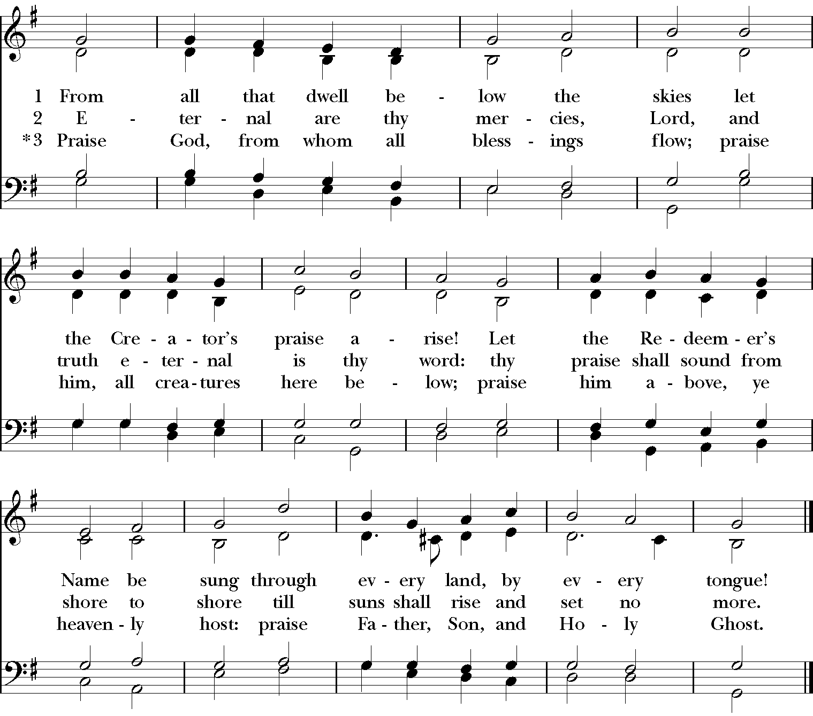

**The Holy Communion**

**The Great Thanksgiving** Eucharistic Prayer A *BCP* 361

Celebrant The Lord be with you.

**People And also with you.**

Celebrant Lift up your hearts.

**People We lift them to the Lord.**

Celebrant Let us give thanks to the Lord our God.

**People It is right to give God thanks and praise.**

Celebrant It is right, and a good and joyful thing, always and everywhere to give thanks to you,

Father Almighty, Creator of heaven and earth through Jesus Christ our Lord; for by water and the Holy Spirit you have made us a new people in Jesus Christ our Lord, to show forth your glory in all the world.

Therefore we praise you, joining our voices with Angels and Archangels and with all the company of heaven, who for ever sing this hymn to proclaim the glory of your Name:

*Sanctus* LEVAS 253

*Please continue to stand or kneel as you are able.*

Celebrant Holy and gracious Father: In your infinite love you made us for yourself, and, when we had fallen into sin and become subject to evil and death, you, in your mercy, sent Jesus Christ, your only and eternal Son, to share our human nature, to live and die as one of us, to reconcile us to you, the God and Father of all.

He stretched out his arms upon the cross, and offered himself, in obedience to your will, a perfect sacrifice for the whole world.  
  
On the night he was handed over to suffering and death, our Lord Jesus Christ took bread; and when he had given thanks to you, he broke it, and gave it to his disciples, and said, "Take, eat: This is my Body, which is given for you. Do this for the  
remembrance of me."

After supper he took the cup of wine; and when he had given thanks, he gave it to them, and said, "Drink this, all of you: This is my Blood of the new Covenant, which is shed for you and for many for the forgiveness of sins. Whenever you drink  
it, do this for the remembrance of me."

Celebrant Therefore we proclaim the mystery of faith:

**People Christ has died.  
Christ is risen.  
Christ will come again.**

Celebrant We celebrate the memorial of our redemption, O Father, in this sacrifice of praise and thanksgiving. Recalling his death, resurrection, and ascension, we offer you these gifts.

Sanctify them by your Holy Spirit to be for your people the Body and Blood of your Son, the holy food and drink of new and unending life in him. Sanctify us also that we may faithfully receive this holy Sacrament, and serve you in unity, constancy,  
and peace; and at the last day bring us with all your saints into the joy of your eternal kingdom.

All this we ask through your Son Jesus Christ: By him, and with him, and in him, in the unity of the Holy Spirit all honor and glory is yours, Almighty Father, now and for ever.

**The Great Amen** LEVAS 261

Celebrant And now, as our Savior Christ has taught us, we are bold to pray,

**People Our Father, who art in heaven,**

**hallowed be thy Name,  
  thy kingdom come,  
   thy will be done,  
       on earth as it is in heaven.  
Give us this day our daily bread.  
And forgive us our trespasses,  
    as we forgive those  
        who trespass against us.  
And lead us not into temptation,  
    but deliver us from evil.  
For thine is the kingdom,  
    and the power, and the glory,  
    for ever and ever. Amen.**

**The Breaking of the Bread**

Celebrant Alleluia, Christ our Passover is sacrificed for us.

**People Therefore let us keep the feast. Alleluia.**

Celebrant The gifts of God for the People of God. Take them in remembrance that Christ died for you, and feed on him in your hearts by faith, with thanksgiving.

Wherever you are on your journey of faith,

**People You are welcome at this table.**

*Please follow the guidance of the ushers to approach the altar to receive communion. Gluten free wafers are available.*

*Guide my feet* W819

**The Post Communion Prayer**

CelebrantLet us pray.

**People Loving God, we give you thanks for restoring us in your image and nourishing us with spiritual food in the Sacrament of Christ’s Body and Blood. Now send us forth a people, forgiven, healed, renewed; that we may proclaim your love to the world and continue in the risen life of Christ our Savior. Amen.**

**The Blessing**Celebrant Life is short, and we do not have much time to gladden the hearts of those who walk

this way with us. So, be swift to love and make haste to be kind; and the blessing of

God Almighty, the Father, the Son, and the Holy Spirit, be among you, and remain

with you always. **Amen.**

**The Dismissal of the Community**

Deacon Let us go forth into the world rejoicing in the power of the Spirit.

**People Thanks be to God.**

**Prayer List**

The Prayer List is prayed on a regular basis by our Monday night Intercessory Prayer Group.  We invite you to incorporate praying the list into your own prayer practices. To add a name to the prayer list, email [prayerbox@stjamesaustin.org](mailto:prayerbox@stjamesaustin.org). Prayer requests from the website will be auto-forwarded to the pastoral care ministry and the office.

We pray for (3 weeks list):  the Thompson family, the Henna family, Jim Burgess, Horace Bledsoe, and Mohamad Ali, Sr.

We also pray for those with long-term needs: Kevin Reed, The Rev. Dr. Sondra Coleman, Historic St. Matthias Episcopal Church, Ashville, NC., Geneva Elliott, Larry Schanki, Amy, Sharon Bennett, Aziza, Jeremy and Shelby, Jimmy Alexander, Mahealani, Robin Clough Powell, Melinda King, John Baxton, Mary Ellen, Curt Jones, James Gibson, Carolyn Caffrey, Michele Bondy,  Jeremy Alexander, Clarence, Lorenza, Donna Plowman, Johann and Susanna, Judy Jenkins, Nancy Gabin, Wiley Williams, Michael Hughes, Anqet, Susan Gunn, BJ Taylor,  Russel Taulli, Pedro E., Robin Fuller, Kisa Niewenhuis, Frank Weir and his family, Candice Brown, Jacob Schumacher and his family, Shirley Gordon, Bowen W., Vanessa Williams, Jim Burgess, Cindy, Jason and Jalen Castillo, Niesha Jones, Truitt Ray, Jerry, Marty, Emma McPherson, Pat, Kamilah Myrie, Tom and Dee Esquivel, Sammie A. Eppright, David Batty, Samuel Carothers, Anna Pecorino, Philip and family,  John White, Brigitte Rhedin, Dan Shaw, Kirk Richter, Raymond Coleman, Cecilia Harris, Lily Thomas, Sandra Gilkey, Leslie Rose, Sean Calloway, Miles Calloway, Carrie Eppright-Givens,  Clayton Givens, Roland Brown, Joy Roswell, Gaye Evans, Rose Watley, Carolyn Caffrey, Joseph Naranjo, Margaret Ann Bledsoe, Brandy,  Andrea, Vanessa, Lorenza, Mrs. Lakeyshia Brown, Pam Beachley, Stephanie Smith,  Elizabeth Sherar Gammon and Steven Sherar, Rebecca Kary, Sherry Ward, Carrie Schumacher, William Collier, Adrian Spears, Mark Werner, Myrna, Evelyn Marie Taylor, Nellie White, Gail Jackson, Richard Ezell, Mary Glennie, Edith Conde and family, Jacob Blake, John Paul Guajardo, Richard White, Andre Watkins, Jana Murphy, Justin Howell and his family, Bruce Blackwell,  Doug Lawrie, Tara Turner, Gertrude Fowler, Claudette Milne, Frankie Scott, Mark McCrary, Kési Anderson, Rev. James Palmore, Cleo B. , Jason A., Reed B., Angelina, Mike C., Diane Hoffman, Brian M, Joyce, Ganelle, Noah, Thor, Troy, Allissa, Charlene Moore, Eugenia Hayes, Tim and Shalmah,  Carol Daughtry, Rachel and Daniel, Rebekah, Diane Neill,  Cecile, Mildred Grimble, Margie Lawson, Melvin Alfred, Natrice Harding, Anne Osbourne, Richelle Easley,  Patricia Harding,  Brandon Williams, Joey Ramirez, Marvin Sykes, Max and his mother, Paul Gill, Samuel Kraemer-Dahlin, Jacquelyn Ferrell Mccadden, Ursula Ferrell Jackson, Ronnie Yarmuck, Bertha Malone, Samah Al Adawi, Hazel Livingston, Arthur Shelton, Caren Bradshaw; and for all who are incarcerated and for their families, and all the refugees throughout the world. God of hope, comfort and restore all who suffer in body, mind or spirit.

We pray for all who have died, including Carolyn Crisp Gipson, mother of Marci Henna and Vashti Thompson, wife of the Rev. Edward Thompson.  Notes of condolences may be sent to the Henna family at 9011 Atwater Cove, Austin, Tx 78733 and to the Thompson family at 3608 Mocha Trail, Austin, Tx 78728.

**Announcements**

**Be a Jazz Angel**

Angels are sponsors who help make Jazz at St. James’ possible every year! Your Jazz Angel sponsorship includes tickets to the concert on the night(s) of your choice as well as exclusive tickets for our Jazz Angels Banquet, 5-7 pm on Saturday, November 16.

Make your Jazz Angel reservation at [https://www.jazzatstjames.org/angels/](https://www.jazzatstjames.org/angels/  )or at St. James’ on Sunday. There will be table in the narthex. For more information, contact office@stjamesaustin.org.

**New to St. James'? Interested in making a commitment to Christian community?**

This semester we are offering two newcomers classes in English for adults and youth. Maybe you are new to our community, and you want to meet other newcomers as well as ministry leaders so that you can figure out how to connect more deeply. Maybe you are interested in baptism or confirmation, in reception from another denomination or reaffirmation of your vows when the bishop visits on December 22. Maybe you want to learn more about our Episcopal identity or the history of St. James'. All of these are good reasons to register for one of these classes.

Class Option A: Sundays, 12-1 pm, September 29-November 3. This in-person 6-session class includes both basics of the faith and specifics of St. James' life. There is a little light reading. Okay if you miss a class.

Class Option B: Saturdays, 12-3 pm, December 7 & 14. These two in-person Saturday sessions cover the same ground as Option A but require a slightly longer attention span. Good news: Lunch provided.

Interested? Contact Rev. Eileen at **rector@stjamesaustin.org**

**Stewardship Kickoff , October 6, 12-1 pm**

Today, join us for lunch as we look forward to setting new tables of welcome in 2025. Learn about the difference your generosity makes.

**Mueller Tuesdays at the Overture, October 8, 7 pm:**

Mueller Tuesdays begin again in the Cork Room at the Overture (4818 Berkman Dr). Join us for Bible Study.  Mueller Tuesdays are on the 2nd and 4th Tuesdays of the month.

**St. James' 20s & 30s Wednesday, October 9, 7-8:30 pm**

Join us for bible study and conversation in Founders Hall.

**Vashti Thompson Memorial Service, October 17, 3 pm**

Please consider joining us in celebrating Vashti Thompson's life on Friday, October 18. We will hold a memorial service at St. James’.

**Parish Workday, October 18, 9 am to 12 pm**

Join us for our fall/winter Parish Workday between 9 am and 12 pm and help make our grounds look good. We will have the tools; you bring the willing hands!

**Dr. James Edwin Polk Memorial Service at Wesley United Methodist Church, October 19, 12 pm**

Join the Austin Jazz community as they honor the life of Dr. James Edwin Polk. A memorial service will be held at Wesley United Methodist Church, 1164 San Bernard St. In addition to being an phenomenal musician, Dr. Polk was one of our jazz headliners and longtime friend of St. James’.

**Jazz at St. James’, November 15-17**

Join us for two unforgettable evenings of live jazz music on November 15 and 16 and a Jazz Mass on Sunday, November 17 at 10:30 am, at St. James' Episcopal Church. Celebrate three decades of incredible performances in a beautiful and sacred setting. The sparkling brilliance of our headliner Tia Fuller will move you and lift your spirit. Don't miss this special milestone event - mark your calendars now! Get the schedule, sponsorship opportunities, and your tickets at [**https://www.jazzatstjames.org/**](https://www.jazzatstjames.org/)**.**

**Volunteers needed!**

Welcome Table needs volunteers for Neighbor 2 Neighbor. Did you know that we have been distributing almost as many bags of food on Tuesdays as we did during the height of the pandemic? The need is great! Small teams of work colleagues are welcome. Contact Emily at emily@welcometable.org for more information.

**Emergency Pastoral Care Line** • 512•677•7991