St. James’ Episcopal Church
Morning Prayer for the Fourth Sunday in Lent

The Service of Morning Prayer can be found on p. 75 of your Book of Common Prayer.

Instrumental prelude Amazing Grace

Jesus said, “If anyone would come after me, let him deny himself and take up his cross and follow me.” Mark 8:34

Penitential Litany
Hold us in your Mercy
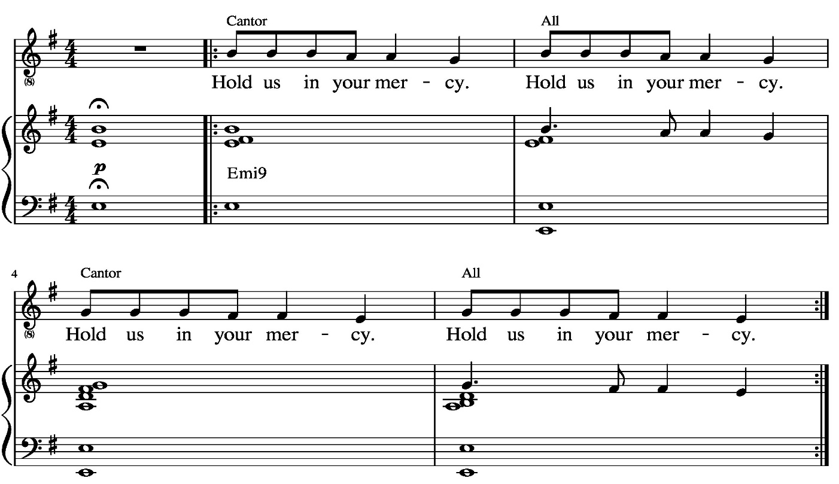

Antiphon
Maker’s love poured out from heaven, hold us in your mercy.
Mercy’s word made flesh among us, hold us in your mercy.
Born as one of homeless pilgrims, hold us in your mercy.
Sent to bring the poor good news, hold us in your mercy.

You, who shared the sinner’s table, hold us in your mercy.
You, who cleansed the leper’s flesh, hold us in your mercy.
You, who shared our life and labor, hold us in your mercy.
You, who chose to walk our roads, hold us in your mercy.

You, who silence raging demons, hold us in your mercy.
You, who bid the storm be silent, hold us in your mercy.
You, whose cross has gone before us, hold us in your mercy.
You, who bear our cross with us, hold us in your mercy.

Innocent, you faced the guilty, hold us in your mercy.
One in death with us forever, hold us in your mercy.
Come and break the chains that bind us; hold us in your mercy.
Free us from addiction’s prison; hold us in your mercy.
Break the power of the darkness; hold us in your mercy.
Let us rise to life with you; hold us in your mercy.

Officiant Let us confess our sins against God and our neighbor.

In the silence we call to mind the brokenness in ourselves and in our world that yearns to be healed.

Officiant and People together,
Most merciful God,
we confess that we have sinned against you
in thought, word, and deed,
by what we have done,
and by what we have left undone.
We have not loved you with our whole heart;
we have not loved our neighbors as ourselves.
We are truly sorry and we humbly repent.
For the sake of your Son Jesus Christ
have mercy on us and forgive us;
that we may delight in your will,
and walk in your ways,
to the glory of your Name. Amen.

Officiant
Almighty God have mercy on you, forgive you all your sins through our Lord Jesus Christ, strengthen you in all goodness, and by the power of the Holy Spirit keep you in eternal life. Amen.
The Invitatory and Psalter
Officiant Lord, open our lips.
People And our mouth shall proclaim your praise.

Officiant and People
Glory to the Father, and to the Son, and to the Holy Spirit: as it was in the beginning, is now, and will be for ever. Amen.

Officiant The Lord is full of compassion and mercy:
People Come let us adore him.

O How He Loves You and Me LEVAS 35

Officiant The Lord is full of compassion and mercy:
People Come let us adore him.

The Psalm Psalm 23

The Lord is my shepherd;
I shall not be in want.

He makes me lie down in green pastures
and leads me beside still waters.

He revives my soul
and guides me along right pathways for his Name's sake.
Though I walk through the valley of the shadow of death,
I shall fear no evil;
for you are with me;
your rod and your staff, they comfort me.

You spread a table before me in the presence of those who trouble me;
you have anointed my head with oil,
and my cup is running over.

Surely your goodness and mercy shall follow me all the days of my life,
and I will dwell in the house of the Lord for ever.

Glory to the Father, and to the Son, and to the Holy Spirit:
as it was in the beginning, is now, and will be for ever. Amen.

The Lessons

A Reading from the First Book of Samuel 1 Samuel 16:1-13

The Lord said to Samuel, “How long will you grieve over Saul? I have rejected him from being king over Israel. Fill your horn with oil and set out; I will send you to Jesse the Bethlehemite, for I have provided for myself a king among his sons.” Samuel said, “How can I go? If Saul hears of it, he will kill me.” And the Lord said, “Take a heifer with you, and say, ‘I have come to sacrifice to the Lord.’ Invite Jesse to the sacrifice, and I will show you what you shall do; and you shall anoint for me the one whom I name to you.” Samuel did what the Lord commanded, and came to Bethlehem. The elders of the city came to meet him trembling, and said, “Do you come peaceably?” He said, “Peaceably; I have come to sacrifice to the Lord; sanctify yourselves and come with me to the sacrifice.” And he sanctified Jesse and his sons and invited them to the sacrifice.

When they came, he looked on Eliab and thought, “Surely the Lord’s anointed is now before the Lord.” But the Lord said to Samuel, “Do not look on his appearance or on the height of his stature, because I have rejected him; for the Lord does not see as mortals see; they look on the outward appearance, but the Lord looks on the heart.” Then Jesse called Abinadab, and made him pass before Samuel. He said, “Neither has the Lord chosen this one.” Then Jesse made Shammah pass by. And he said, “Neither has the Lord chosen this one.” Jesse made seven of his sons pass before Samuel, and Samuel said to Jesse, “The Lord has not chosen any of these.” Samuel said to Jesse, “Are all your sons here?” And he said, “There remains yet the youngest, but he is keeping the sheep.” And Samuel said to Jesse, “Send and bring him; for we will not sit down until he comes here.” He sent and brought him in. Now he was ruddy, and had beautiful eyes, and was handsome. The Lord said, “Rise and anoint him; for this is the one.” Then Samuel took the horn of oil, and anointed him in the presence of his brothers; and the spirit of the Lord came mightily upon David from that day forward. Samuel then set out and went to Ramah.

The Word of the Lord.
People Thanks be to God.

I want to walk as a child of light H490

A Reading from the Letter to the Ephesians Ephesians 5:8-14

Once you were darkness, but now in the Lord you are light. Live as children of light— for the fruit of the light is found in all that is good and right and true. Try to find out what is pleasing to the Lord. Take no part in the unfruitful works of darkness, but instead expose them. For it is shameful even to mention what such people do secretly; but everything exposed by the light becomes visible, for everything that becomes visible is light. Therefore it says,
“Sleeper, awake!
Rise from the dead,
and Christ will shine on you.”

The Word of the Lord.
People Thanks be to God.

Heal me hands of Jesus WLP 773

The Gospel John 9:1-41

Narrator The Holy Gospel of our Lord Jesus Christ according to John.
People Glory to you, Lord Christ.

Narrator As Jesus walked along, he saw a man blind from birth. His disciples asked him,

Disciples Rabbi, who sinned, this man or his parents, that he was born blind?

Jesus Neither this man nor his parents sinned; he was born blind so that God’s works might be revealed in him. We must work the works of him who sent me while it is day; night is coming when no one can work. As long as I am in the world, I am the light of the world.

Narrator When he had said this, he spat on the ground and made mud with the saliva and spread the mud on the man’s eyes, saying to him,

Jesus Go, wash in the pool of Siloam
Narrator (which means Sent). Then he went and washed and came back able to see. The neighbors and those who had seen him before as a beggar began to ask,

Neighbors Is this not the man who used to sit and beg?

Narrator Some were saying,

Some Neighbors It is he.

Narrator Others were saying,

Other Neighbors No, but it is someone like him.

Narrator He kept saying,

Man Born Blind I am the man.

Narrator But they kept asking him,

Neighbors Then how were your eyes opened?

Man Born Blind The man called Jesus made mud, spread it on my eyes, and said to me, ‘Go to Siloam and wash.’ Then I went and washed and received my sight.

Neighbors Where is he?

Man Born Blind I do not know.

Narrator They brought to the Pharisees the man who had formerly been blind. Now it was a sabbath day when Jesus made the mud and opened his eyes. Then the Pharisees also began to ask him how he had received his sight. He said to them,

Man Born Blind He put mud on my eyes. Then I washed, and now I see.

Narrator Some of the Pharisees said,

Some Pharisees This man is not from God, for he does not observe the sabbath.

Narrator But others said,

Other Pharisees How can a man who is a sinner perform such signs?

Narrator And they were divided. So they said again to the blind man,
Pharisees What do you say about him? It was your eyes he opened.
Man Born Blind He is a prophet.

Narrator The Jews did not believe that he had been blind and had received his sight until they called the parents of the man who had received his sight and asked them,

Some Pharisees and Other Neighbors
Is this your son, who you say was born blind? How then does he now see?”

Narrator His parents answered,

Parents We know that this is our son, and that he was born blind; but we do not know how it is that now he sees, nor do we know who opened his eyes. Ask him; he is of age. He will speak for himself.”

Narrator His parents said this because they were afraid of the Jews; for the Jews had already agreed that anyone who confessed Jesus to be the Messiah would be put out of the synagogue. Therefore his parents said,

Parents He is of age; ask him.

Narrator So for the second time they called the man who had been blind, and they said to him,

Some Pharisees and Other Neighbors
Give glory to God! We know that this man is a sinner.

Man Born Blind I do not know whether he is a sinner. One thing I do know, that though I was blind, now I see.

Some Pharisees and Other Neighbors
What did he do to you? How did he open your eyes?

Man Born Blind I have told you already, and you would not listen. Why do you want to hear it again? Do you also want to become his disciples?

Narrator Then they reviled him, saying,

Some Pharisees and Other Neighbors
You are his disciple, but we are disciples of Moses. We know that God has spoken to Moses, but as for this man, we do not know where he comes from.
Man Born Blind Here is an astonishing thing! You do not know where he comes from, and yet he opened my eyes. We know that God does not listen to sinners, but he does listen to one who worships him and obeys his will. Never since the world began has it been heard that anyone opened the eyes of a person born blind. If this man were not from God, he could do nothing.

Some Pharisees and Other Neighbors
You were born entirely in sins, and are you trying to teach us?

Narrator And they drove him out. Jesus heard that they had driven him out, and when he found him, he said,

Jesus Do you believe in the Son of Man?

Man Born Blind And who is he, sir? Tell me, so that I may believe in him.

Jesus You have seen him, and the one speaking with you is he.

Man Born Blind Lord, I believe.

Narrator And he worshiped him.

Jesus I came into this world for judgment so that those who do not see may see, and those who do see may become blind.
Narrator Some of the Pharisees near him heard this and said to him,

Some Pharisees Surely we are not blind, are we?

Jesus If you were blind, you would not have sin. But now that you say, ‘We see,’ your sin remains.

Narrator The Gospel of the Lord.
People Praise to you, Lord Christ.

Sermon The Rev. Eileen O’Brien

The Apostles' Creed

Officiant and People together,

I believe in God, the Father almighty,
creator of heaven and earth.
I believe in Jesus Christ, his only Son, our Lord.
He was conceived by the power of the Holy Spirit
and born of the Virgin Mary.
He suffered under Pontius Pilate,
was crucified, died, and was buried.
He descended to the dead.
On the third day he rose again.
He ascended into heaven,
and is seated at the right hand of the Father.
He will come again to judge the living and the dead.
I believe in the Holy Spirit,
the holy catholic Church,
the communion of saints,
the forgiveness of sins,
the resurrection of the body,
and the life everlasting. Amen.

The Prayers `

Officiant The Lord be with you.
People And also with you.
Officiant Let us pray.

Officiant and People
Our Father, who art in heaven,
hallowed be thy Name,
thy kingdom come,
thy will be done,
on earth as it is in heaven.
Give us this day our daily bread.
And forgive us our trespasses,
as we forgive those
who trespass against us.
And lead us not into temptation,
but deliver us from evil.
For thine is the kingdom,
and the power, and the glory,
for ever and ever. Amen.

Officiant Gracious Father, whose blessed Son Jesus Christ came down from heaven to bethe true bread which gives life to the world: Evermore give us this bread, that hemay live in us, and we in him; who lives and reigns with you and the Holy Spirit, one God, now and for ever. Amen.

Officiant O God, you make us glad with the weekly remembrance of the glorious resurrection of your Son our Lord: Give us this day such blessing through our worship of you, that the week to come may be spent in your favor; through Jesus Christ our Lord. Amen.

Officiant Heavenly Father, in you we live and move and have our being: We humbly pray you so to guide and govern us by your Holy Spirit, that in all the cares and occupations of our life we may not forget you, but may remember that we are ever walking in your sight; through Jesus Christ our Lord. Amen.

Intercessor Lord God, you are the light of the world. Let your light shine in this time of darkness and fear. You walked among us as Jesus of Nazareth in order to work the works of light. In this time when many are without work, or worry about losing work, may we remember your power to heal, transform, and renew.
Hear us when we say:
People Lord, have mercy.

Intercessor May we demonstrate your love through caution and mercy, and continue to find ways to care for our neighbors.
People Lord, have mercy.

Intercessor May the bluebonnets and buds of spring refresh even the most exhausted among us.
People Lord, have mercy.

Intercessor May our Lenten journey lead us with ever greater faith and joy into our life with you.
People Lord, have mercy.

Intercessor May our fasting make us ready for the banquet you have prepared for us.
People Lord, have mercy.

Intercessor May your comfort and mercy come to all who suffer and despair. For whom shall we pray? (Pause to hear the prayers of others and to offer your own.)
Hear us when we say
People Lord, have mercy.

Intercessor May those who have died find life with you. Whom shall we remember and not forget? (Pause to hear the prayers of others and to offer your own.)
Hear us when we say:
People Lord, have mercy.

Intercessor Though weeping may last the night, joy comes in the morning. We give thanks, O God, for the wellsprings of hope in our lives. (Pause to give thanks with the community.)
Hear us when we say:
People Lord, have mercy.

Officiant God of all places, people, and times, you remind us that the vulnerable reveal as much of your presence in the world as anyone. In this hour when a virus spreads through the land and upsets the normal order of things, help us to trust in your amazing grace, that some who are blind may yet see, some who are sick may yet be well, and, in the words of your saint Julian of Norwich, all will be well and all manner of things will be well. All this we ask through Jesus Christ our Lord. Amen.

Officiant Lord Jesus Christ, you stretched out your arms of love on the hard wood of the cross that everyone might come within the reach of your saving embrace: So clothe us in your Spirit that we, reaching forth our hands in love, may bring those who do not know you to the knowledge and love of you; for the honor of your Name. Amen.

I heard the voice of Jesus H692

The General Thanksgiving

Officiant and People
Almighty God, Father of all mercies,
we your unworthy servants give you humble thanks
for all your goodness and loving-kindness
to us and to all whom you have made.
We bless you for our creation, preservation,
and all the blessings of this life;
but above all for your immeasurable love
in the redemption of the world by our Lord Jesus Christ;
for the means of grace, and for the hope of glory.
And, we pray, give us such an awareness of your mercies,
that with truly thankful hearts we may show forth your praise,
not only with our lips, but in our lives,
by giving up our selves to your service,
and by walking before you
in holiness and righteousness all our days;
through Jesus Christ our Lord,
to whom, with you and the Holy Spirit,
be honor and glory throughout all ages. Amen.

A Prayer of St. Chrysostom
Almighty God, you have given us grace at this time with one accord to make our common supplication to you; and you have promised through your well-beloved Son that when two or three are gathered together in his Name you will be in the midst of them: Fulfill now, O Lord, our desires and petitions as may be best for us; granting us in this world knowledge of your truth, and in the age to come life everlasting. Amen.

Officiant Let us bless the Lord.
People Thanks be to God.

Officiant Glory to God whose power, working in us, can do infinitely
more than we can ask or imagine: Glory to God from
generation to generation in the Church, and in Christ Jesus
for ever and ever. Amen. Ephesians 3:20,21

